HARDWARE AND COMPONENTS BASICS

ASSIGNMENT DAY 5
TASK1.List all the main components you find inside a desktop PC after opening the cabinet, and write a short description (1-2 lines) for each.
Component | Description
Motherboard | The main circuit board that connects and allows communication between all computer components.
CPU (Processor) | The brain of the computer that performs calculations and executes instructions.
RAM (Memory) | Temporary memory used to store data and programs currently in use.
GPU (Graphics Card) | Processes graphics and video output for gaming and multimedia tasks.
HDD (Hard Disk Drive) | Permanent storage device used to store files, software, and operating systems.
SSD (Solid State Drive) | Faster storage device that improves system boot and application loading times.
SMPS (Power Supply Unit) | Converts AC power from the wall socket into DC power for computer components.
CPU Cooler (Fan/Heatsink) | Removes heat from the processor to prevent overheating.
Cabinet/Case Fans | Improve airflow inside the computer case.
SATA Cables | Connect storage devices to the motherboard.
CMOS Battery | Maintains BIOS settings and system time when power is disconnected.
Expansion Cards | Additional hardware such as Wi-Fi cards, sound cards, or capture cards.

TASK2. Take clear photos or draw labeled diagrams of each step as you disassemble a desktop PC, and organize them in a document with captions explaining what you did at each step.<br><br><em><strong>Hint:</strong> Include steps like unplugging power, removing side panel, disconnecting cables, and removing RAM, HDD/SSD, and motherboard.</em>

STEP1-Switched off the computer and disconnected the power cable before opening the cabinet.
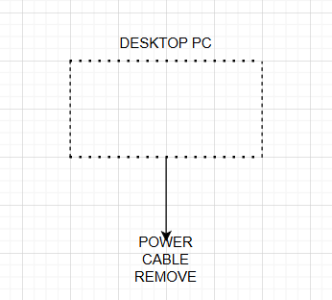

STEP2-Removed the side cabinate to access internal hardware components.
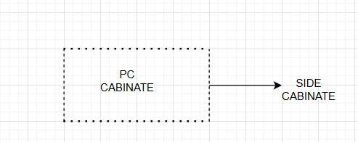

STEP3-Disconnected all power and data cables before removing components.

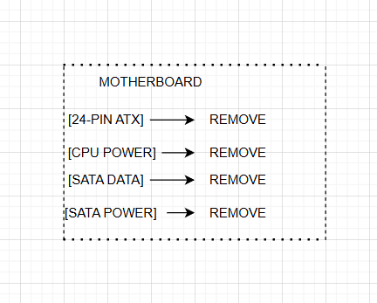

STEP4- Opened the retaining clips and carefully removed the RAM module.
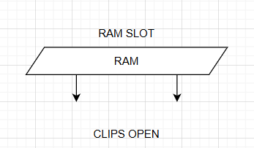

STEP5- Disconnected SATA cables and removed the storage drive.

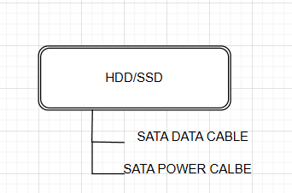

STEP6- Removed PCIe power cable and carefully pulled the graphics card from the PCIe slot.
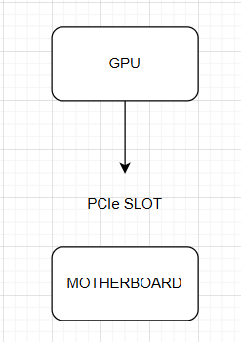

STEP7- Removed the CPU cooler assembly to access the processor.

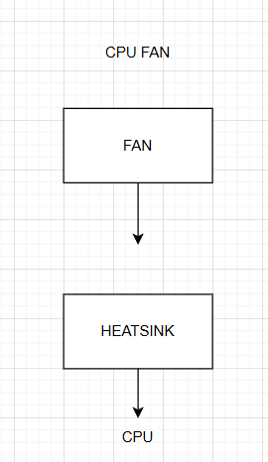

STEP8- Removed motherboard mounting screws and carefully lifted the motherboard out of the cabinet.

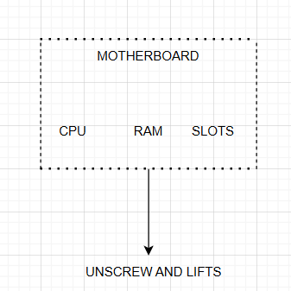
TASK3. Reassemble the PC you disassembled, documenting each step with a brief explanation of what you connected or installed and why the order matters
Step 1: Install the Motherboard
- Place the motherboard inside the cabinet.
- Align it with the standoffs and screw holes.
- Secure it using the motherboard screws.
Step 2: Install the CPU Cooler
- Place the CPU cooler over the CPU.
- Tighten the mounting screws or clips.
- Connect the CPU fan cable to the CPU_FAN header on the motherboard.
Step 3: Reinstall the RAM Modules
- Align the notch on the RAM module with the slot.
- Insert the RAM into the correct DIMM slot.
- Press firmly until the retaining clips lock automatically
Step 4: Reinstall the Graphics Card (GPU)
- Insert the GPU into the PCIe x16 slot.
- Push until the PCIe retention clip locks.
- Secure the GPU with screws.
Step 5: Reinstall the HDD/SSD
- Mount the HDD or SSD in its drive bay.
- Secure it using screws or the mounting bracket.
- Connect the SATA data cable to the motherboard.
- Connect the SATA power cable from the SMPS.
Step 6: Reconnect the Power Supply Cables
- Connect the 24-pin ATX power connector to the motherboard.
- Connect the 8-pin (4+4) CPU power connector.
- Connect PCIe power cables to the GPU (if required).
- Connect SATA power cables to storage drives.
Step 7: Reconnect Front Panel Connectors
- Connect the Power Switch cable.
- Connect the Reset Switch cable.
- Connect Power LED and HDD LED cables.
- Connect front USB and audio cables.
Step 8: Reconnect Case Fans
- Connect all cabinet fan cables to the motherboard or fan hub.
Step 9: Inspect All Connections
- Verify that all cables are securely connected.
- Check that RAM, GPU, and storage devices are firmly seated
Step 10: Close the Cabinet
- Reattach the side panel.
- Tighten the side-panel screws.
Step 11: Connect External Devices
- Connect the monitor, keyboard, mouse, speakers, and power cable.
Step 12: Power On and Test
- Turn on the SMPS switch.
- Press the power button.
- Verify that:
- Fans spin normally.
- Monitor displays output.
- Windows boots successfully.

TASK4. Create a checklist of safety precautions and tools needed before starting the PC assembly/disassembly process, and explain why each is important.
TOOLS REQUIRED:-
Tool | Purpose
Phillips Screwdriver | Removes and installs screws.
Anti-Static Wrist Strap | Prevents electrostatic discharge damage.
Small Container | Holds screws safely.
Soft Brush | Removes dust from components.
Flashlight | Helps view components inside the case.

SAFETY PRECAUTION:-
Precaution | Why It Is Important
Disconnect Power Supply | Prevents electric shock and component damage.
Wear Anti-Static Wrist Strap | Protects sensitive electronic components from static electricity.
Handle Components by Edges | Avoids damaging chips and circuits.
Work on a Clean Surface | Prevents loss of screws and contamination.
Do Not Force Connectors | Prevents broken ports and connectors.
Keep Liquids Away | Avoids short circuits and hardware damage.
Organize Screws Carefully | Makes reassembly easier and prevents missing parts.
Read Device Manual | Ensures proper installation and removal procedures.

